CEBD-1251

**Superstore Data Analysis**

horizontal line

# Introduction

This Report analyze sales performance and KPI metrics for APAC Market to help the sales team achieving profitable sales based on customer interests, products and categories which making good sales and profit also highlight unprofitable stores to improve it. This report would be ensuring repeat business from profitable customers and products and increasing the Sales.

This Report will provide analysis for the following criteria:

* APAC Countries KPI
* Subcategory and Products KPI
* Customer behaviour
* Discounts

### APAC Countries KPI

Since we need overview on the countries sales, performance and shipping cost to get general idea about APAC KPI so here below the interactive Map of APAC Countries.

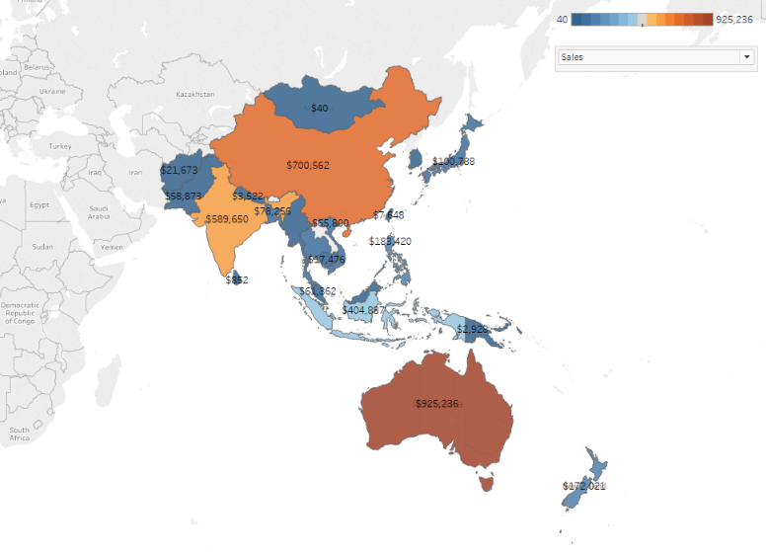

In this interactive map we can choose between 3 measures:

1. Sales per country
2. Profit per country
3. Shipping Cost per country

All these measures are color coded and the value of the measure is plotted on the map, So we can know who has the best and worst of the selected measure.

If we select “Sales” measure we will find that “Australia” has the best sales value, but selecting “Profit” measure we will find that “China” has the best Profit

### Subcategory and Products KPI:

In this dashboard we need to do more inside to have a better understanding about profit, sales revenue, sales quantity and order per category and subcategory.

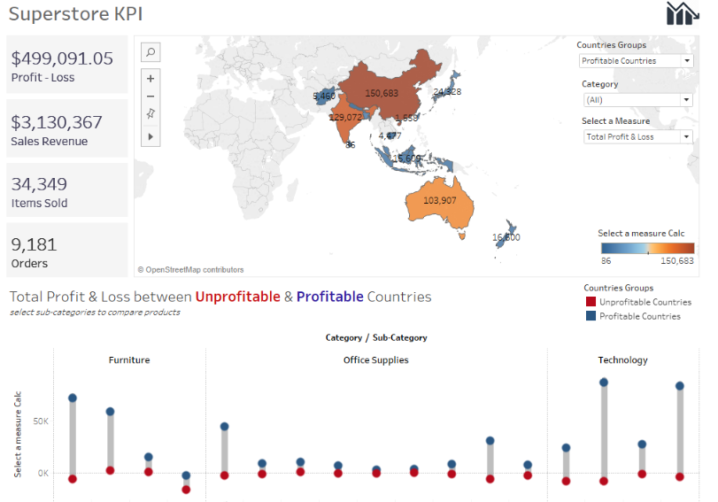

We can filter through the following:

* Profitable and Unprofitable country groups dimension
* Category dimension
* Profit measure in total or per order

For example lets select “Profitable Countries” from “Country Groups”, also from “Category” select lets select “Technology” and choose “Total Profit & Loss” in “Select a Measure”

Then the color coded map will show that China has the best profit in technology category and in the left of the dashboard will be showed the total profit, sales revenue, sales quantity and number of order for profitable countries in APAC per technology category.

Also based on the category selection which is in our example “Technology” we will see total profit & loss comparison between profitable and unprofitable countries per category.

Now lets discover the below dashboard to dive more in products profit by scatter the product.

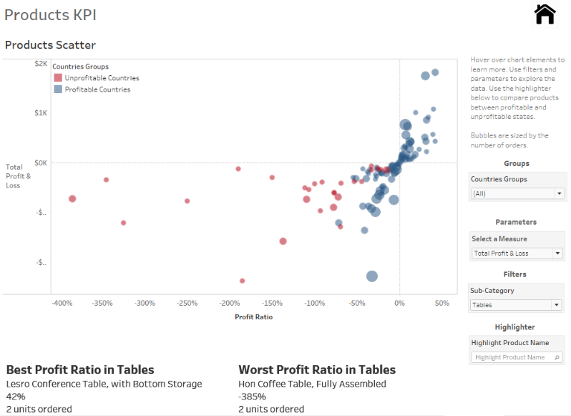

Each bubble represents a product and can filter through the following:

* Profitable and Unprofitable country groups dimension
* Subcategory dimension
* Profit measure in total or per order
* Product

Once selecting our filters then in the bottom part of the dashboard we will be notified by the best and worst product in the selected subcategory

Also we can select a product in the selected subcategory and this product will be highlighted in the scatter with profit info.

**So this analysis will give the insight view about countries, categories, subcategories and products sales and profit in APAC market to increase the profitability in some counties based on the category and product KPI is showing in the report**